Step 0 Intake + Interview Filing Status, Dependency

Interview Notes: (See also: General Notes)
- Helen has not lived with her husband, Peter Rosemont, for several years. His SSN is 782-00-yyyy. Helen is not claiming an exemption for Peter.
- Peter did not itemize last year nor will he be itemizing this year.
- Helen rents a home and pays $1,400.00/month rent.

Documents:
791-xx-yyyy
Helen E. Rosemont
Helen E. Rosemont

Step 1 Basic Information

TP Form / Note | TS Screen | Notes
 | Basic Information – Filing Status
Intake Sheet | What is your filing Status? | Select Filing status from drop down.  Answer: Filing Status: Married Filing Separate  TS: Do not check either box on the Married Separate Screen.  Continue
SS Card  Intake Sheet  I-Note 1  G-Note 2 | Personal Information  Taxpayer Information  Address & Phone Number | Hint: Use Name and SSN from SS card. (Not Intake Sheet)  Hint: SSN format YYY-00-0752  TS: Birth date can be entered using drop down menu or filling in the field.  TS: Check any of the “Check here” questions that apply – Answer: Presidential Election Campaign Fund for TP  TS: Enter Zip code- TaxSlayer fills in city and state. Correct if required  TS: The only spouse information that is required is his name and SSN.  TS: Enter New Jersey as the Resident State  TS: Select Continue
Intake Sheet  G-Note 3 | Just a Few More Questions (NJ Info) | TS: Select Municipality from drop down menu (Listed by county). Start typing Burlington to quickly scroll down. Medford Twsp is in Burlington County  TS: Select Yes or No for the Gubernatorial Election Fund. See Intake Sheet page 3 and General Note 3.  Answer: Yes for TP,  TS: Enter Five Digit Pin for TP and SP. Any 5-digit number.  TS: Select Continue
 | Dependents/ Qualifying Person  Do you have any Dependents or Qualifying Person(s) to claim on your return? | TS: Answer is “No”

Federal Refund: 0 NJ Refund Amount: 0

Step 2 W-2 Hair Do Salon

W-2  Hair Do Salon | Left Menu  Federal Section  Enter Myself  Income  Wages & Salaries Form W-2- Begin | Hint: Make corrections so that information matches the information on the W-2  Hint: If the name and address of the employer come up after inputting the employer Identification Number, check that the information is correct  Hint: Always round up for amounts ending in --.50  Hint: Box 14 NJ Codes are selected from drop down menu. All other entries in box 14 are lumped under “Other”  Hint: If NJ State EIN auto populates, check to be sure it is correct  TS: Click continue NJ warning  TS: Click Continue back to income

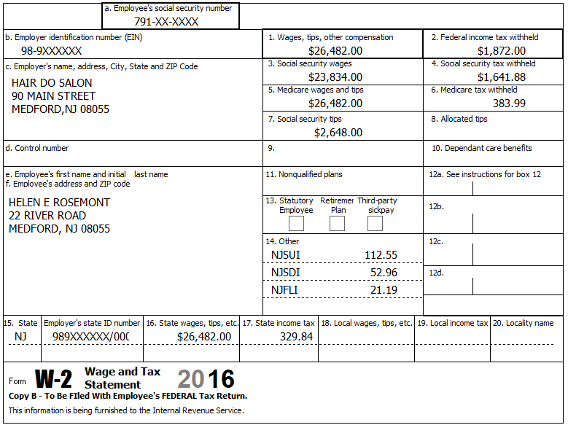

Federal Refund: -83 NJ Refund Amount: -46

Step 3 Unemployment 1099-G

TP Form / Note | TS Screen | Notes
1099-G  NJ Dep of Labor | UnemploymentCompensation Form 1099-G Box 1 – Begin  Add or Edit a 1099-G - Begin | TS: This 1099G worksheet is for the:Taxpayer  Hint: Phone number not required  Hint: State information not required  Continue

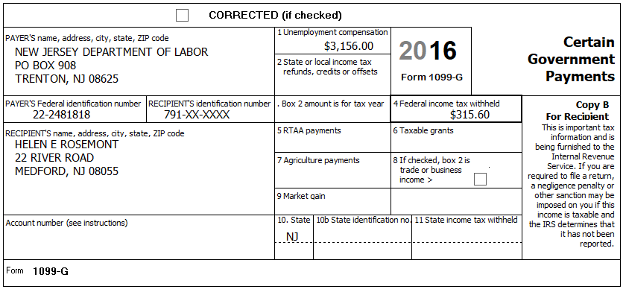

Federal Refund: -240 NJ Refund Amount: -46

Step 4 Federal Deductions, Adjustments & Credits
TP Form / Note | TS Screen | Notes
 | Left Menu  Federal Section  Deductions  Enter Myself  Itemized Deductions  Taxes You Paid - Begin | Go to the Sales Tax Worksheet and enter NJ, Zip Code, and 366 days living in the state  Continue back to Health Insurance
 | -Compare Standard vs Itemized Deductions  Left Menu - Federal Section -Deductions – Enter Myself – Compare Deductions - Begin | Check to see if using itemized deductions or standard deductions. Itemized =517  Std = 6,300  Continue back to Health Insurance

Federal Refund: -240 NJ Refund Amount: -46

Step 5 Health Insurance
TP Form / Note | TS Screen | Notes
G-Note 2 | Left Menu-Health Insurance  Start Questionnaire | Answer questions in the Health Insurance Section

Helen had health insurance that met Minimum Essential Coverage rules for the entire year. She did not purchase it through the marketplace. Peter is not part of Helen’s Health Household.

Federal Refund: -240 NJ Refund Amount: -46

Step 6 New Jersey Return

TP Form / Note | TS Screen | Notes
I-Note 1,3  G-Note 2,3,4 | State Return –Edit  Enter Myself  Basic Information  Credits  - Property Tax/Deduction | Hint: Use the NJ Checklist to enter NJ items  HINT: Check Basic Information – Default values will not appear as selected  Continue  Answer questions  Hint: Use scratch pad at TP4F to determine the proper value for Property Tax Paid  Hint: Property Taxes Paid = (rent*.18) 1400X12X.18=3024  Hint: Taxpayer meets Property Tax Eligibility Requirements  Hint: Did you and your spouse have the same residence for 2016?  Answer: No  Hint: Were you a homeowner in 2016  Answer: No  Continue back to the beginning of the State Return

Helen has not lived with her husband, Peter Rosemont, for several years. His SSN is 782-00-yyyy. Helen is not claiming an exemption for Peter.

Helen rents a home and pays $1,400.00/month rent.

Federal Refund: -240 NJ Refund Amount: 7

Step 7 Prepare for e-file

Intake Sheet  G Note 5 | Left Menu – e-file – | TS – Clear up any diagnostic messages (if any)  TS: Select Federal Return Type “E:file: Direct Debit”  TS: No entries in Fees section except for Client email address  TS – Pin numbers for e-file are automatically selected  TS: Select State Refund Type “E:file: Direct Deposit”  TS: Enter bank information. Name of bank not required.  - Enter the amount of the tax payment  - Debit phone number is TP phone number  TS: Skip Third Party Designee Info  TS – Questions – Answer questions from Intake sheet Part VII, lines 5.6 and 7, Supplemental Intake Sheet,  TS: Skip TP ID Information Screen  Save  You are Done

.

She wants to handle any state refund / amount due like their federal refund / amount due

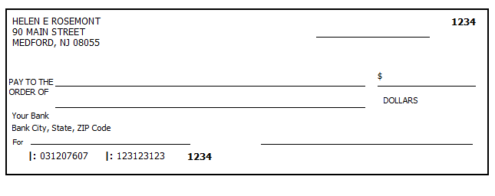

Federal Refund: -240 NJ Refund Amount: 7

